PROGRAM CYCLE GUIDANCE


ADS 201 Additional Help
RESULTS FRAMEWORK INDICATOR ANNEX
TEMPLATE

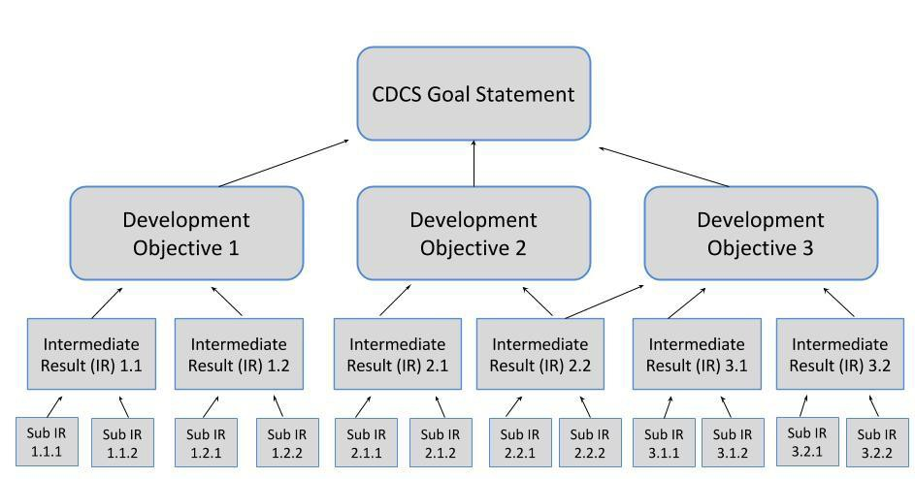
ADS 201 states that preliminary or illustrative performance or context indicator(s) must be included in the Results Framework Indicator Annex rather than in the Development Hypothesis or Results Framework sections of the CDCS. The following template has been developed to provide a structured approach to organizing such an annex. Missions should adjust the tables as necessary to reflect the number of DOs, IRs, and Sub-IRs outlined in their CDCS.

No indicators are required for measuring progress toward achieving a Goal

No indicators are required for measuring progress toward achieving a DO, though performance or context indicators may be selected as appropriate and useful

A Mission must identify at least one performance indicator to measure progress toward the achievement of each IR

A Mission must identify at least one performance indicator to measure progress toward the achievement of each Sub-IR


SEPTEMBER 2016/PAGE 1

Objective or Result |  |  | Indicators
DO1 – Enter DO language here |  |  | No indicators are required at this level, though performance or context indicators may selected if applicable and useful
 | IR 1.1 – Enter IR language here |  | At least one performance indicator must be identified for each IR
 |  | IR 1.1.1 – Enter Sub-IR language here | At least one performance indicator must be identified for each Sub-IR
 |  | IR 1.1.2 – Enter Sub-IR language here | At least one performance indicator must be identified for each Sub-IR
 |  | IR 1.1.3 – Enter Sub-IR language here | At least one performance indicator must be identified for each Sub-IR
 |  | IR 1.1.4 – Enter Sub-IR language here | At least one performance indicator must be identified for each Sub-IR
 | IR 1.2 – Enter IR language here |  | At least one performance indicator must be identified for each IR
 |  | IR 1.2.1 – Enter Sub-IR language here | At least one performance indicator must be identified for each Sub-IR
 |  | IR 1.2.2 – Enter Sub-IR language here | At least one performance indicator must be identified for each Sub-IR
 |  | IR 1.2.3 – Enter Sub-IR language here | At least one performance indicator must be identified for each Sub-IR

Objective or Result |  |  | Indicators
IR 1.2.4 – Enter Sub-IR language here |  |  | At least one performance indicator must be identified for each Sub-IR
 | IR 1.3 – Enter IR language here |  | At least one performance indicator must be identified for each IR
 |  | IR 1.3.1 – Enter Sub-IR language here | At least one performance indicator must be identified for each Sub-IR
 |  | IR 1.3.2 – Enter Sub-IR language here | At least one performance indicator must be identified for each Sub-IR
 |  | IR 1.3.3 – Enter Sub-IR language here | At least one performance indicator must be identified for each Sub-IR
 |  | IR 1.3.4 – Enter Sub-IR language here | At least one performance indicator must be identified for each Sub-IR
 | IR 1.4 – Enter IR language here |  | At least one performance indicator must be identified for each IR
 |  | IR 1.4.1 – Enter Sub-IR language here | At least one performance indicator must be identified for each Sub-IR
 |  | IR 1.4.2 – Enter Sub-IR language here | At least one performance indicator must be identified for each Sub-IR
 |  | IR 1.4.3 – Enter Sub-IR language here | At least one performance indicator must be identified for each Sub-IR
 |  | IR 1.4.4 – Enter Sub-IR language here | At least one performance indicator must be identified for each Sub-IR

Objective or Result |  |  | Indicators
DO2 – Enter DO language here |  |  | No indicators are required at this level, though performance or context indicators may selected if applicable and useful
 | IR 2.1 – Enter IR language here |  | At least one performance indicator must be identified for each IR
 |  | IR 2.1.1 – Enter Sub-IR language here | At least one performance indicator must be identified for each Sub-IR
 |  | IR 2.1.2 – Enter Sub-IR language here | At least one performance indicator must be identified for each Sub-IR
 |  | IR 2.1.3 – Enter Sub-IR language here | At least one performance indicator must be identified for each Sub-IR
 |  | IR 2.1.4 – Enter Sub-IR language here | At least one performance indicator must be identified for each Sub-IR
 | IR 2.2 – Enter IR language here |  | At least one performance indicator must be identified for each IR
 |  | IR 2.2.1 – Enter Sub-IR language here | At least one performance indicator must be identified for each Sub-IR
 |  | IR 2.2.2 – Enter Sub-IR language here | At least one performance indicator must be identified for each Sub-IR
 |  | IR 2.2.3 – Enter Sub-IR language here | At least one performance indicator must be identified for each Sub-IR
 |  | IR 2.2.4 – Enter Sub-IR language here | At least one performance indicator must be identified for each Sub-IR

Objective or Result |  |  | Indicators
 | IR 2.3 – Enter IR language here |  | At least one performance indicator must be identified for each IR
 |  | IR 2.3.1 – Enter Sub-IR language here | At least one performance indicator must be identified for each Sub-IR
 |  | IR 2.3.2 – Enter Sub-IR language here | At least one performance indicator must be identified for each Sub-IR
 |  | IR 2.3.3 – Enter Sub-IR language here | At least one performance indicator must be identified for each Sub-IR
 |  | IR 2.3.4 – Enter Sub-IR language here | At least one performance indicator must be identified for each Sub-IR
 | IR 2.4 – Enter IR language here |  | At least one performance indicator must be identified for each IR
 |  | IR 2.4.1 – Enter Sub-IR language here | At least one performance indicator must be identified for each Sub-IR
 |  | IR 2.4.2 – Enter Sub-IR language here | At least one performance indicator must be identified for each Sub-IR
 |  | IR 2.4.3 – Enter Sub-IR language here | At least one performance indicator must be identified for each Sub-IR
 |  | IR 2.4.4 – Enter Sub-IR language here | At least one performance indicator must be identified for each Sub-IR

Objective or Result |  |  | Indicators
DO3 – Enter DO language here |  |  | No indicators are required at this level, though performance or context indicators may selected if applicable and useful
 | IR 3.1 – Enter IR language here |  | At least one performance indicator must be identified for each IR
 |  | IR 3.1.1 – Enter Sub-IR language here | At least one performance indicator must be identified for each Sub-IR
 |  | IR 3.1.2 – Enter Sub-IR language here | At least one performance indicator must be identified for each Sub-IR
 |  | IR 3.1.3 – Enter Sub-IR language here | At least one performance indicator must be identified for each Sub-IR
 |  | IR 3.1.4 – Enter Sub-IR language here | At least one performance indicator must be identified for each Sub-IR
 | IR 3.2 – Enter IR language here |  | At least one performance indicator must be identified for each IR
 |  | IR 3.2.1 – Enter Sub-IR language here | At least one performance indicator must be identified for each Sub-IR
 |  | IR 3.2.2 – Enter Sub-IR language here | At least one performance indicator must be identified for each Sub-IR
 |  | IR 3.2.3 – Enter Sub-IR language here | At least one performance indicator must be identified for each Sub-IR
 |  | IR 3.2.4 – Enter Sub-IR language here | At least one performance indicator must be identified for each Sub-IR

Objective or Result |  |  | Indicators
 | IR 3.3 – Enter IR language here |  | At least one performance indicator must be identified for each IR
 |  | IR 3.3.1 – Enter Sub-IR language here | At least one performance indicator must be identified for each Sub-IR
 |  | IR 3.3.2 – Enter Sub-IR language here | At least one performance indicator must be identified for each Sub-IR
 |  | IR 3.3.3 – Enter Sub-IR language here | At least one performance indicator must be identified for each Sub-IR
 |  | IR 3.3.4 – Enter Sub-IR language here | At least one performance indicator must be identified for each Sub-IR
 | IR 3.4 – Enter IR language here |  | At least one performance indicator must be identified for each IR
 |  | IR 3.4.1 – Enter Sub-IR language here | At least one performance indicator must be identified for each Sub-IR
 |  | IR 3.4.2 – Enter Sub-IR language here | At least one performance indicator must be identified for each Sub-IR
 |  | IR 3.4.3 – Enter Sub-IR language here | At least one performance indicator must be identified for each Sub-IR
 |  | IR 3.4.4 – Enter Sub-IR language here | At least one performance indicator must be identified for each Sub-IR

Objective or Result |  |  | Indicators
DO4 – Enter DO language here |  |  | No indicators are required at this level, though performance or context indicators may selected if applicable and useful
 | IR 4.1 – Enter IR language here |  | At least one performance indicator must be identified for each IR
 |  | IR 4.1.1 – Enter Sub-IR language here | At least one performance indicator must be identified for each Sub-IR
 |  | IR 4.1.2 – Enter Sub-IR language here | At least one performance indicator must be identified for each Sub-IR
 |  | IR 4.1.3 – Enter Sub-IR language here | At least one performance indicator must be identified for each Sub-IR
 |  | IR 4.1.4 – Enter Sub-IR language here | At least one performance indicator must be identified for each Sub-IR
 | IR 4.2 – Enter IR language here |  | At least one performance indicator must be identified for each IR
 |  | IR 4.2.1 – Enter Sub-IR language here | At least one performance indicator must be identified for each Sub-IR
 |  | IR 4.2.2 – Enter Sub-IR language here | At least one performance indicator must be identified for each Sub-IR
 |  | IR 4.2.3 – Enter Sub-IR language here | At least one performance indicator must be identified for each Sub-IR
 |  | IR 4.2.4 – Enter Sub-IR language here | At least one performance indicator must be identified for each Sub-IR

Objective or Result |  |  | Indicators
 | IR 4.3 – Enter IR language here |  | At least one performance indicator must be identified for each IR
 |  | IR 4.3.1 – Enter Sub-IR language here | At least one performance indicator must be identified for each Sub-IR
 |  | IR 4.3.2 – Enter Sub-IR language here | At least one performance indicator must be identified for each Sub-IR
 |  | IR 4.3.3 – Enter Sub-IR language here | At least one performance indicator must be identified for each Sub-IR
 |  | IR 4.3.4 – Enter Sub-IR language here | At least one performance indicator must be identified for each Sub-IR
 | IR 4.4 – Enter IR language here |  | At least one performance indicator must be identified for each IR
 |  | IR 4.4.1 – Enter Sub-IR language here | At least one performance indicator must be identified for each Sub-IR
 |  | IR 4.4.2 – Enter Sub-IR language here | At least one performance indicator must be identified for each Sub-IR
 |  | IR 4.4.3 – Enter Sub-IR language here | At least one performance indicator must be identified for each Sub-IR
 |  | IR 4.4.4 – Enter Sub-IR language here | At least one performance indicator must be identified for each Sub-IR

