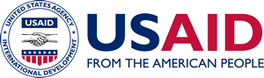

Vetting Language for Pre-Award/Pre-Modification Letters

A Mandatory Reference for ADS Chapter 319

New Edition Date: 01/15/2021

Responsible Office: M/MPBP

File Name: 319man_011521

The [Applicable] Program Team will insert the following language in pre-award letters (PALs) or pre-modification letters (PMLs) to presumptive recipients that request a PAL/PML to implement programs:

This authorization is subject to the successful negotiation and award of a grant or

cooperative agreement, or modification of the same, in accordance with your application, and in no way obligates the United States Government or the U.S. Agency for International Development (USAID) to reimburse your organization for any expenses incurred in the event USAID does not make an award or modification. USAID additionally notes that any resulting award will or modification be subject to vetting in accordance with USAID’s [insert applicable Vetting Mission Order or Vetting Standard Operating Procedures], which could affect the allowability of costs, potentially including previously incurred costs.